Reinforcement learning:

MDP – markov decision processes

In an MDP, we have a decision maker, called an *agent*, that interacts with the *environment* it's placed in. These interactions occur sequentially over time. At each time step, the agent will get some representation of the environment’s *state*. Given this representation, the agent selects an*action* to take. The environment is then transitioned into a new state, and the agent is given a*reward* as a consequence of the previous action.

Components of an MDP:

* Agent
* Environment
* State
* Action
* Reward

This process of selecting an action from a given state, transitioning to a new state, and receiving a reward happens sequentially over and over again, which creates something called a *trajectory*that shows the sequence of states, actions, and rewards.

Throughout this process, it is the agent’s goal to maximize the total amount of rewards that it receives from taking actions in given states. This means that the agent wants to maximize not just the immediate reward, but the *cumulative* rewards it receives over time.

It is the agent’s goal to maximize the cumulative rewards.

Alright, let’s get a bit mathy and represent an MDP with mathematical notation. This will make things easier for us going forward.

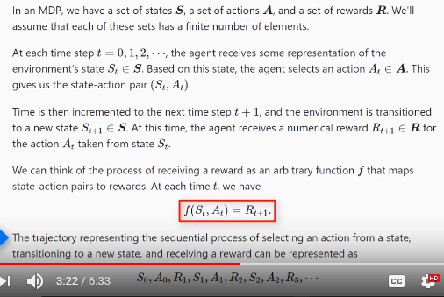

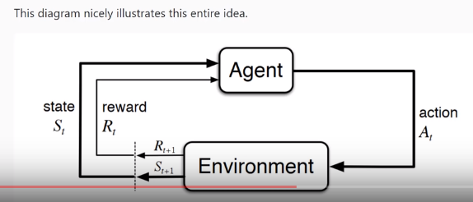

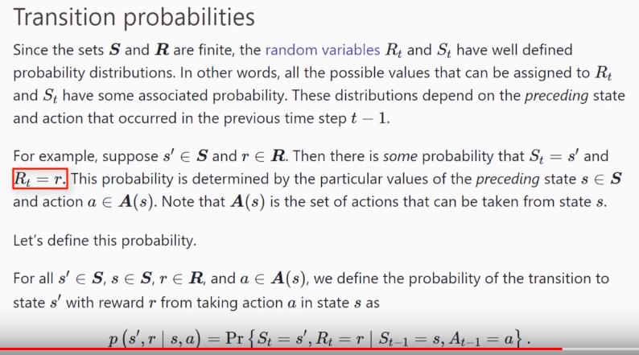

**Expected Return (Episodic tasks)**

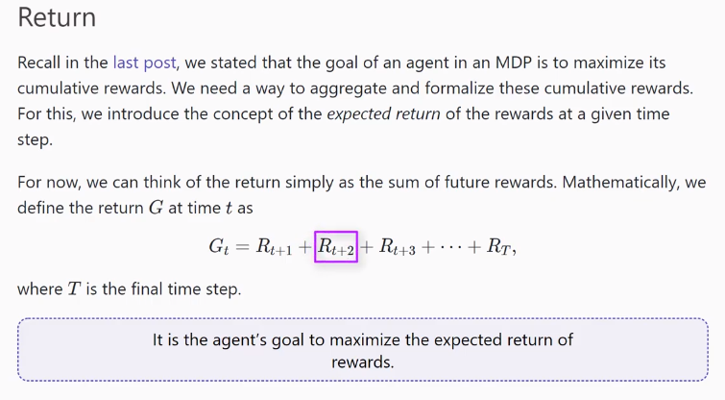

Episodic vs. continuing tasks

In our definition of the expected return, we introduced \(T\), the final time step. When the notion of having a final time step makes sense, the agent-environment interaction naturally breaks up into subsequences, called *episodes*. For example, think about playing a game of pong. Each new round of the game can be thought of as an episode, and the final time step of an episode occurs when a player scores a point.

Each episode ends in a terminal state at time \(T\), which is followed by resetting the environment to some standard starting state or to a random sample from a distribution of possible starting states. The next episode then begins independently from how the previous episode ended.

Formally, tasks with episodes are called *episodic tasks*.

There exists other types of tasks though where the agent-environment interactions don’t break up naturally into episodes, but instead continue without limit. These types of tasks are called*continuing tasks*.

**Discounted Return (continuing tasks):**

Our revision of the way we think about return will make use of *discounting*. Rather than the agent’s goal being to maximize the expected return of rewards, it will instead be to maximize the expected *discounted* return of rewards. Specifically, the agent will be choosing action \(A_t\) at each time \(t\) to maximize the expected discounted return.

It is the agent’s goal to maximize the expected *discounted* return of rewards.

This definition of the discounted return makes it to where our agent will care more about the immediate reward over future rewards since future rewards will be more heavily discounted. So, while the agent does consider the rewards it expects to receive in the future, the more immediate rewards have more influence when it comes to the agent making a decision about taking a particular action.

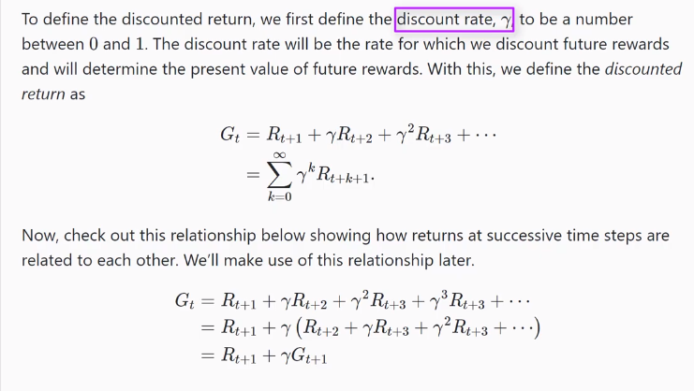

Policies and Value Functions:

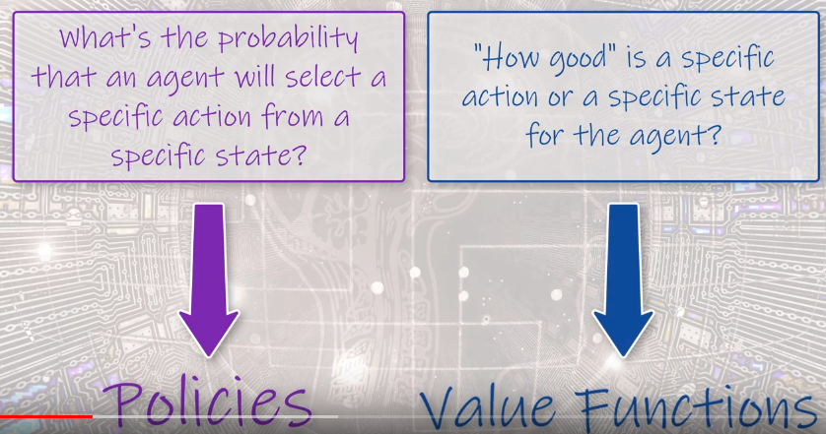

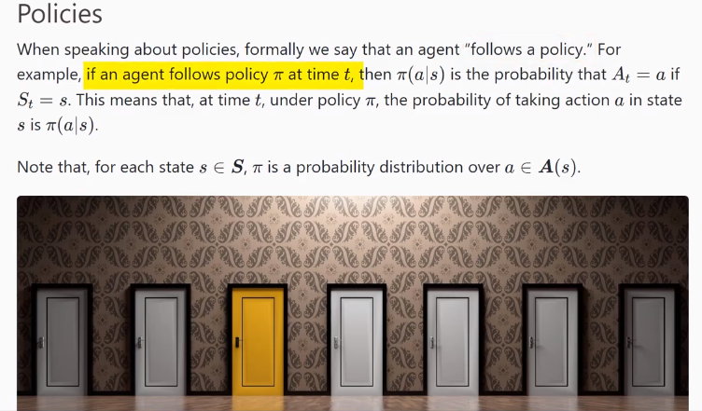

Value Functions:

Value functions are functions of states, or of state-action pairs, that estimate how good it is for an agent to be in a given state, or how good it is for the agent to perform a given action in a given state.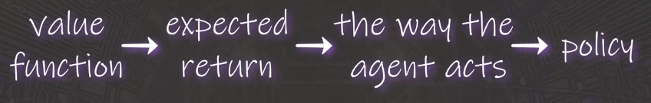

This notion of *how good* a state or state-action pair is is given in terms of expected return. Remember, the rewards an agent expects to receive are dependent on what actions the agent takes in given states. So, value functions are defined with respect to specific ways of acting. Since the way an agent acts is influenced by the policy it's following, then we can see that value functions are defined with respect to policies.

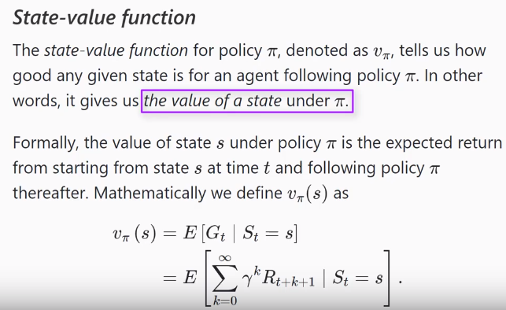

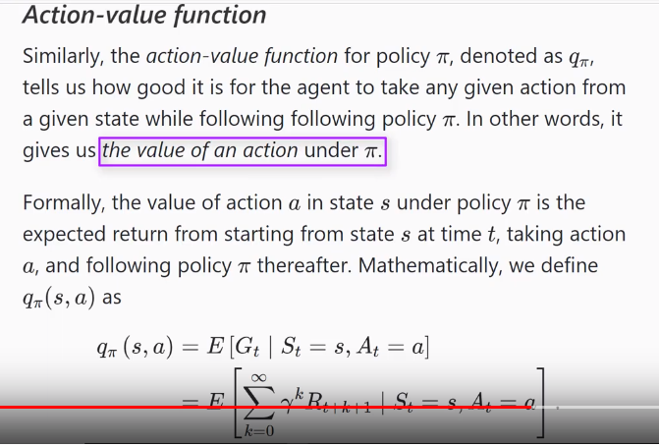

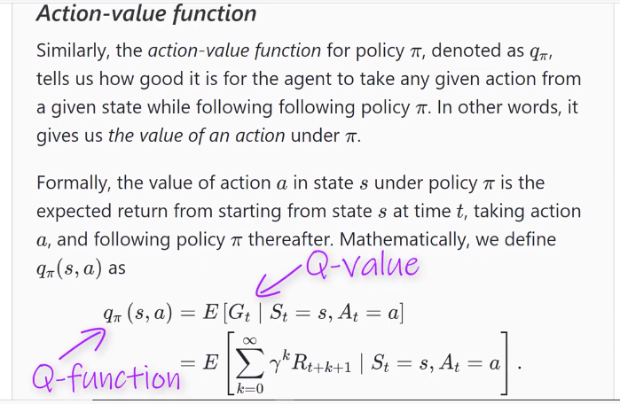

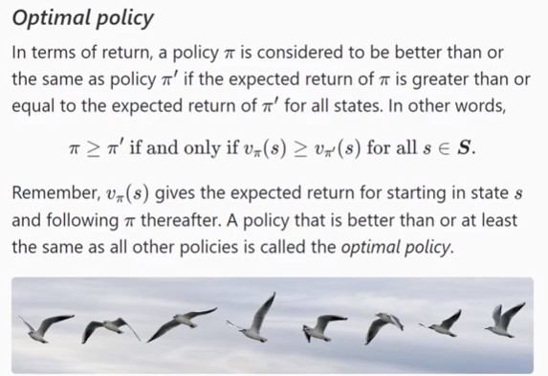

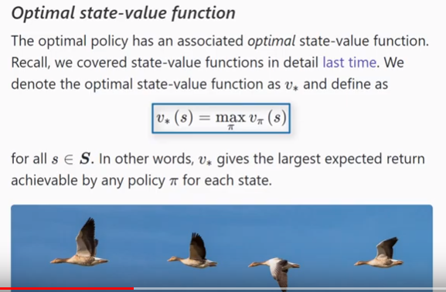

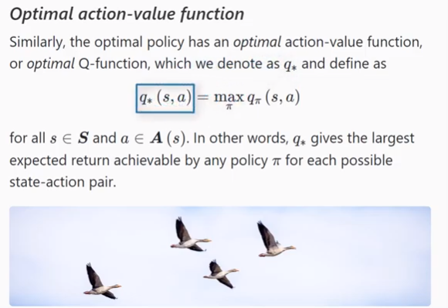

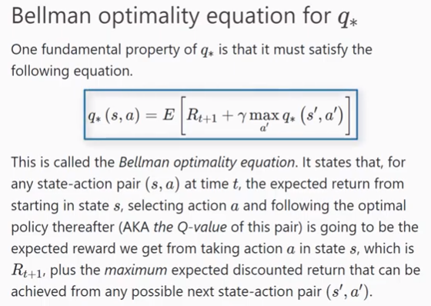

Q-Learning:

The objective of Q-learning is to find a policy that is optimal in the sense that the expected value of the total reward over all successive steps is the maximum achievable. So, in other words, the goal of Q-learning is to find the optimal policy by learning the optimal Q-values for each state-action pair.

### Q-learning with value iteration

First, as a quick reminder, remember that the Q-function for a given policy accepts a state and an action and returns the expected return from taking the given action in the given state and following the given policy thereafter.

Also, remember this Bellman optimality equation for q∗q∗ we discussed [last time](https://deeplizard.com/learn/video/rP4oEpQbDm4)?q∗(s,a)=E[Rt+1+γmaxa′q∗(s′,a′)]q∗(s,a)=E[Rt+1+γmaxa′q∗(s′,a′)]Go take a peak at the explanation we gave previously for this equation if you're a bit rusty on how to interpet this. It will become useful in a moment.

### *Value iteration*

The Q-learning algorithm iteravely updates the Q-values for each state-action pair using the Bellman equation until the Q-function converges to the *optimal* Q-function, q∗q∗. This approach is called *value iteration*. To see exactly how this happens, let’s set up an example, appropriately called *The Lizard Game*.

### An example: *The Lizard Game*

### *The set up*

Suppose we have the following environment shown below. The agent in our environment is the lizard. The lizard wants to eat as many crickets as possible in the least amount of time without stumbling across a bird, which will, itself, eat the lizard.

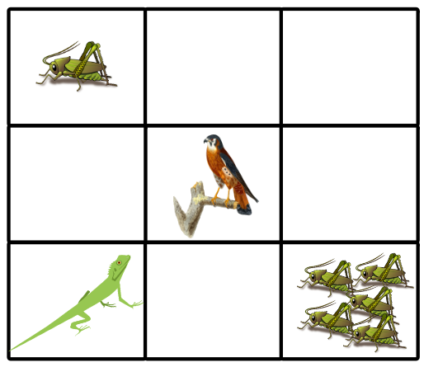

The lizard can move left, right, up, or down in this environment. These are the actions. The states are determined by the individual tiles and where the lizard is on the board at any given time.

If the lizard lands on a tile that has one cricket, the reward is plus one point. Landing on an empty tile is minus one point. A tile with five crickets is plus ten points and will end the episode. A tile with a bird is minus ten points and will also end the episode.

|  |  |
| --- | --- |
| **State** | **Reward** |
| One cricket | +1 |
| Empty | - 1 |
| Five crickets | +10 Game over |
| Bird | - 10 Game over |

Now, at the start of the game, the lizard has no idea how good any given action is from any given state. It’s not aware of anything besides the current state of the environment. In other words, it doesn’t know from the start whether navigating left, right, up, or down will result in a positive reward or negative reward.

Therefore, the Q-values for each state-action pair will all be initialized to zero since the lizard knows nothing about the environment at the start. Throughout the game, though, the Q-values will be iteravely updated using value iteration.

### *Storing Q-values in a Q-table*

We'll be making use of a table, called a *Q-table*, to store the Q-values for each state-action pair. The horizontal axis of the table represents the actions, and the vertical axis represents the states. So, the dimensions of the table are the number of actions by the number of states.

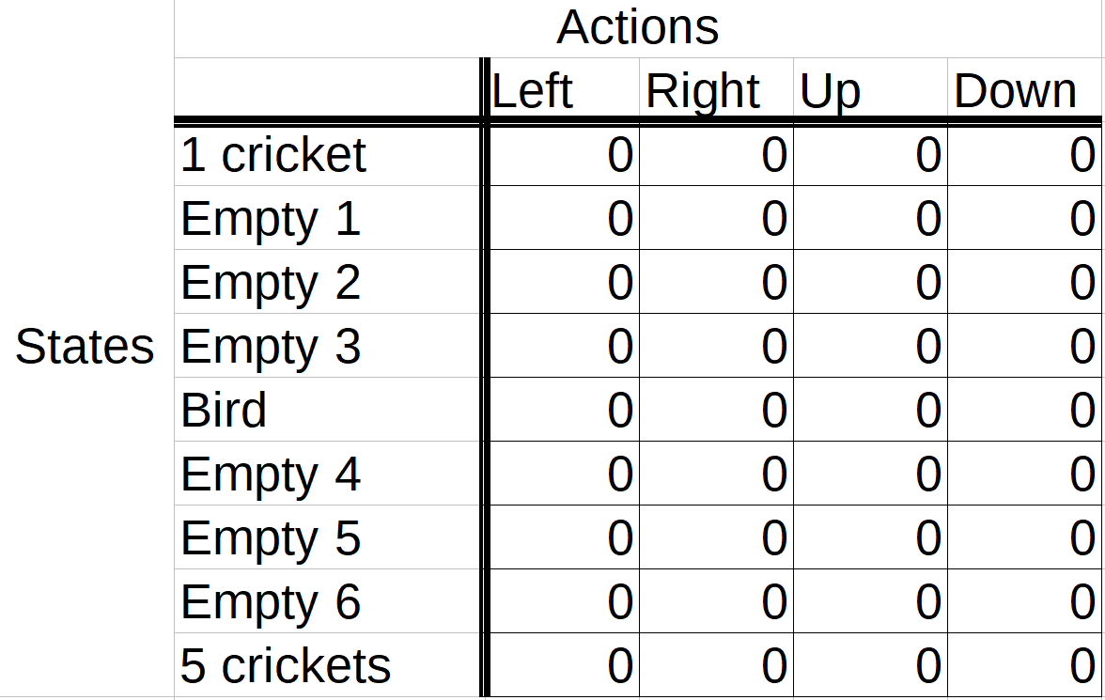

As just mentioned, since the lizard knows nothing about the environment or the expected rewards for any state-action pair, all the Q-values in the table are first initialized to zero. Over time, though, as the lizard plays several episodes of the game, the Q-values produced for the state-action pairs that the lizard experiences will be used to update the Q-values stored in the Q-table.

As the Q-table becomes updated, in later moves and later episodes, the lizard can look in the Q-table and base its next action on the highest Q-value for the current state. This will make more sense once we actually start playing the game and updating the table.

#### Episodes

Now, we’ll set some standard number of episodes that we want the lizard to play. Let’s say we want the lizard to play five episodes. It is during these episodes that the learning process will take place.

In each episode, the lizard starts out by choosing an action from the starting state based on the current Q-values in the table. The lizard chooses the action based on which action has the highest Q-value in the Q-table for the current state.

But, wait... That’s kind of weird for the first actions in the first episode, right? Because all the Q-values are set zero at the start, so there’s no way for the lizard to differentiate between them to discover which one is considered better. So, what action does it start with?

To answer this question, we'll introduce the trade-off beteween *exploration* and *exploitation*. This will help us understand not just how an agent takes its first actions, but how exactly it chooses actions in general.

### Exploration vs. exploitation

*Exploration* is the act of exploring the environment to find out information about it. *Exploitation* is the act of exploiting the information that is already known about the environment in order to maximize the return.

The goal of an agent is to maximize the expected return, so you might think that we want our agent to use exploitation all the time and not worry about doing any exploration. This strategy, however, isn’t quite right.

Think of our game. If our lizard got to the single cricket before it got to the group of five crickets, then only making use of exploitation, going forward the lizard would just learn to exploit the information it knows about the location of the single cricket to get single incremental points infinitely. It would then also be losing single points infinitely just to back out of the tile before it can come back in to get the cricket again.

If the lizard was able to *explore* the environment, however, it would have the opportunity to find the group of five crickets that would immediately win the game. If the lizard *only* explored the environment with no exploitation, however, then it would miss out on making use of known information that could help to maximize the return.

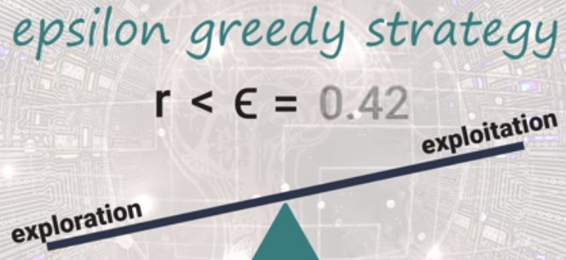

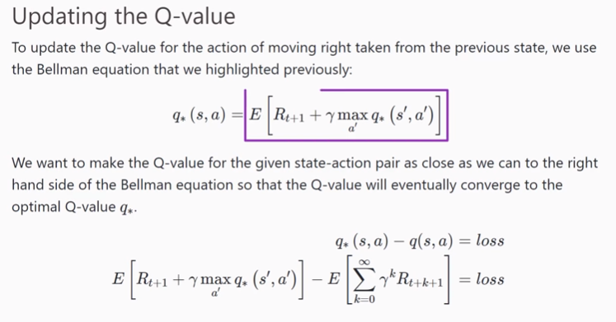

### Deep Q-learning

We’ll make use of a deep neural network to estimate the Q-values for each state-action pair in a given environment, and in turn, the network will approximate the optimal Q-function. The act of combining Q-learning with a deep neural network is called *deep Q-learning*, and a deep neural network that approximates a Q-function is called a *deep Q-Network, or DQN*.

### Deep Q-networks

Suppose we have some arbitrary deep neural network that accepts states from a given environment as input. For each given state input, the network outputs estimated Q-values for each action that can be taken from that state. The objective of this network is to approximate the optimal Q-function, and remember that the optimal Q-function will satisfy the Bellman equation that we covered [previously](https://deeplizard.com/learn/video/rP4oEpQbDm4):

q∗(s,a)=E[Rt+1+γmaxa′q∗(s′,a′)]q∗(s,a)=E[Rt+1+γmaxa′q∗(s′,a′)]

With this in mind, the [loss](https://deeplizard.com/learn/video/Skc8nqJirJg) from the network is calculated by comparing the outputted Q-values to the target Q-values from the right hand side of the Bellman equation, and as with any network, the objective here is to minimize this loss.

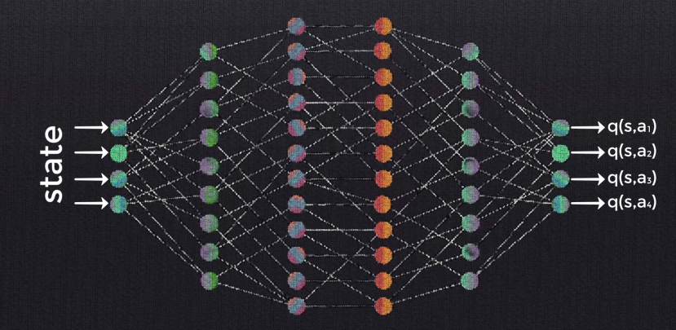

After the loss is calculated, the weights within the network are updated via [SGD](https://deeplizard.com/learn/video/_N5kpSMDf4o) and[backpropagation](https://deeplizard.com/learn/video/XE3krf3CQls), again, just like with any other typical network. This process is done over and over again for each state in the environment until we sufficiently minimize the loss and get an approximate optimal Q-function.

So, take a second now to think about how we previously used the Bellman equation to [compute and update Q-values in our Q-table](https://deeplizard.com/learn/video/mo96Nqlo1L8) in order to find the optimal Q-function. Now, with deep Q-learning, our network will make use of the Bellman equation to estimate the Q-values to find the optimal Q-function. So, we’re still solving the same general problem here, just with a different algorithm. Rather than making use of value iteration to solve the problem, we’re now using a deep neural network.

Alright, we should now have a general idea about what deep Q-learning is and what, at a high level, the deep Q-network is doing. Now, let’s get a little more into the details about the network itself.

### *The input*

We discussed earlier that the network would accept states from the environment as input. Thinking of Frozen Lake, we could easily represent the states using a simple coordinate system from the grid of the environment and use this as input.

SFFF

FHFH

FFFH

HFFG

If we’re in a more complex environment, though, like a video game, for example, then we’ll use images as our input. Specifically, we’ll use still frames that capture states from the environment as the input to the network.

The standard preprocessing done on the frames usually involves converting the RGB data into grayscale data since the color in the image is probably usually not going to affect the state of the environment. Additionally, we’ll typically see some cropping and scaling as well to both cut out unimportant information from the frame and shrink the size of the image.

Now actually, rather than having a single frame represent a single input, we usually will use a stack of a few consecutive frames to represent a single input. So, we would grab, say, four consecutive frames from the video game. We’d then do all the preprocessing on each of these four frames we mentioned earlier – the grayscale conversion, the cropping, and the scaling – and then we’d take the preprocessed frames and stack them on top of each other in the order of which they occurred in the game.

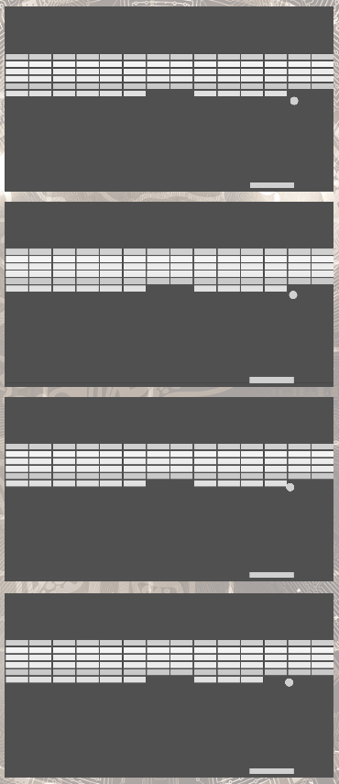

We do this because a single frame usually isn’t going to be enough for our network, or even for our human brains, to fully understand the state of the environment. For example, by just looking at the first single frame above from the Atari game, Breakout, we can’t tell if the ball is coming down to the paddle or going up to hit the block. We also don’t have any indication about the speed of the ball, or which direction the paddle is moving in.

If we look at four consecutive frames, though, then we have a much better idea about the current state of the environment because we now do indeed have information about all of these things that we didn’t know with just a single frame. So, the takeaway is that a stack of frames will represent a single input, which represents the state of the envrionment.

### *The layers*

Now that we know what the input is, the next thing to address is the inner workings of the network – the layers. Well, really, we’re not going to see much more than we’re used to seeing with any other network we’ve already covered. Like, seriously, many deep-Q networks are purely just some convolutional layers, followed by some non-linear activation function, and then the convolutional layers are followed by a couple fully connected layers, and that’s it.

So, the layers used in a DQN are nothing new and nothing to be freaked out about.

If you do need a crash course or a refresher on convolutional neural networks or neural networks in general, then be sure to check out the [Deep Learning Fundamentals series](https://deeplizard.com/learn/playlist/PLZbbT5o_s2xq7LwI2y8_QtvuXZedL6tQU).

### *The output*

The last piece of the network to discuss is the output. The output layer will be a fully connected layer, and it will produce the Q-value for each action that can be taken from the given state that was passed as input.

For example, suppose in a given game, the actions we can take consist of moving left, moving right, jumping, and ducking. Then the output layer would consist of four nodes, each representing one of the four actions. The value produced from a single output node would be the Q-value associated with taking the action that corresponds to that node from the state that was supplied as input to the network.

We won’t see the output layer followed by any activation function since we want the raw, non-transformed Q-values from the network.

### Experience Replay and Replay Memory

With deep Q-networks, we often utilize this technique called *experience replay* during training. With experience replay, we store the agent’s experiences at each time step in a data set called the*replay memory*. We represent the agent’s experience at time tt as etet.

At time tt, the agent's experience etet is defined as this tuple:

et=(st,at,rt+1,st+1)et=(st,at,rt+1,st+1)

This tuple contains the state of the environment stst, the action atat taken from state stst, the reward rt+1rt+1 given to the agent at time t+1t+1 as a result of the previous state-action pair (st,at)(st,at), and the next state of the environment st+1st+1. This tuple indeed gives us a summary of the agent’s*experience* at time tt.

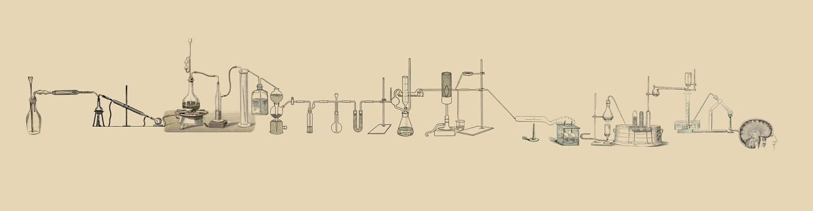

All of the agent's experiences at each time step over all episodes played by the agent are stored in the *replay memory*. Well actually, in practice, we’ll usually see the replay memory set to some finite size limit, NN, and therefore, it will only store the last NN experiences.

This replay memory data set is what we’ll randomly sample from to train the network. The act of gaining experience and sampling from the replay memory that stores these experience is called experience replay.

### *Why use experience replay?*

Why would we choose to train the network on random samples from replay memory, rather than just providing the network with the sequential experiences as they occur in the environment?

A key reason for using replay memory is to break the correlation between consecutive samples.

If the network learned only from consecutive samples of experience as they occurred sequentially in the environment, the samples would be highly correlated and would therefore lead to inefficient learning. Taking random samples from replay memory breaks this correlation.

### Combining a deep Q-network with experience replay

Alright, we now have the idea of experience replay down. From [last time](https://deeplizard.com/learn/video/wrBUkpiRvCA), we should also have an understanding of a general deep Q-network architecture, the data that the network accepts, and the output from the network.

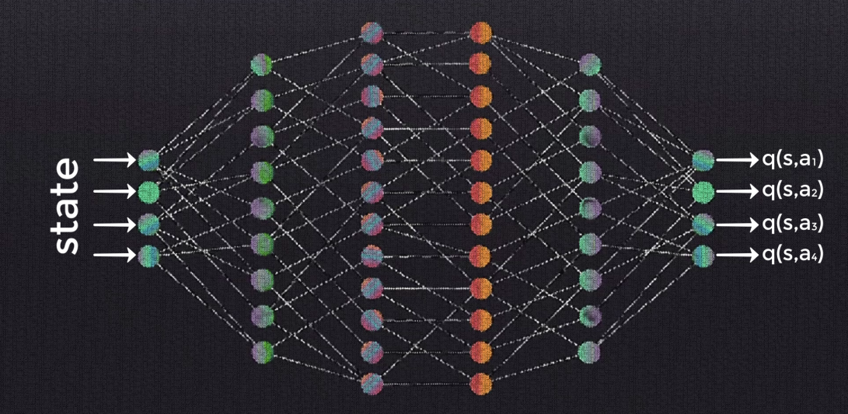

As a quick refresher, remember that the network is passed a state from the environment, and in turn, the network outputs the Q-value for each action that can be taken from that state.

Let’s now bring all of this information in together with experience replay to see how they fit in with each other.

#### Setting up

Before training starts, we first initialize the replay memory data set DD to capacity NN. So, the replay memory DD will hold NN total experiences.

Next, we initialize the network with random weights. We've covered [weight initialization](https://deeplizard.com/learn/video/8krd5qKVw-Q) in the[Deep Learning Fundamentals series](https://deeplizard.com/learn/playlist/PLZbbT5o_s2xq7LwI2y8_QtvuXZedL6tQU), so if you need a refresher on this topic, check that out. The exact same concepts we covered there applies for deep Q-network weight initialization.

Next, for each episode, we initialize the starting state of the episode. In our [previous discussion](https://deeplizard.com/learn/video/wrBUkpiRvCA), we talked about states, including the starting state, being a frame of raw pixels from a game screen as an example.

### *Gaining experience*

Now, for each time step tt within the episode, we either explore the environment and select a random action, or we exploit the environment and select the greedy action for the given state that gives the highest Q-value. Remember, this is the exploration-exploitation trade-off that we discussed in detail in a [previous post](https://deeplizard.com/learn/video/mo96Nqlo1L8).

We then execute the selected action atat in an emulator. So, for example, if the selected action was to move right, then from an emulator where the actions were being executed in the actual game environment, the agent would actually move right. We then observe the reward rt+1rt+1 given for this action, and we also observe the next state of the environment, st+1st+1. We then store the entire experience tuple et=(st,at,rt+1,st+1)et=(st,at,rt+1,st+1) in replay memory DD.

### Wrapping up

Here's a summary of what we have so far:

1. Initialize replay memory capacity.
2. Initialize the network with random weights.
3. *For each episode:*
   1. Initialize the starting state.
   2. *For each time step:*
      1. Select an action.
         * *Via exploration or exploitation*
      2. Execute selected action in an emulator.
      3. Observe reward and next state.
      4. Store experience in replay memory.

### The policy network

After storing an experience in replay memory, we then sample a random batch of experiences from replay memory. For ease of understanding, though, we're going to explain the remaining process for a single sample, and then you can generalize the idea to an entire batch.

Alright, so from a single experience sample from replay memory, we then preprocess the state (grayscale conversion, cropping, scaling, etc.), and pass the preprocessed state to the network as input. Going forward, we’ll refer to this network as the *policy network* since its objective is to approximate the optimal policy by finding the optimal Q-function.

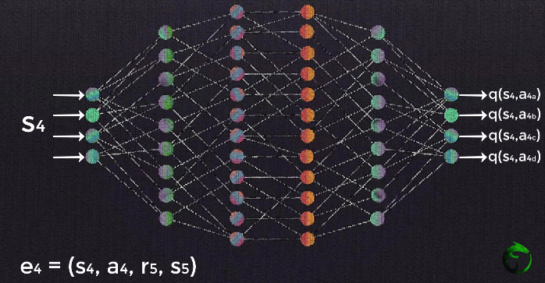

The input state data then forward propagates through the network, using the same forward propagation technique that we’ve discussed for any other general neural network. The model then outputs an estimated Q-value for each possible action from the given input state.

The loss is then calculated. We do this by comparing the Q-value output from the network for the action in the experience tuple we sampled and the corresponding optimal Q-value, or *target Q-value,*for the same action.

Remember, the target Q-value is calculated using the expression from the right hand side of the Bellman equation. So, just as we saw when we initially learned about plain Q-learning earlier in this series, the loss is calculated by subtracting the Q-value for a given state-action pair from the optimal Q-value for the same state-action pair.

### 

### Calculating the maxmax term

When we are calculating the optimal Q-value for any given state-action pair, notice from the equation for calculating loss that we used above, we have this term here that we must compute:

maxa′q∗(s′,a′)maxa′q∗(s′,a′)

Recall that s′s′ and a′a′ are the state and action that occur in the following time step. [Previously](https://deeplizard.com/learn/video/mo96Nqlo1L8), we were able to find this maxmax term by peeking in the Q-table, remember? We'd just look to see which action gave us the highest Q-value for a given state.

Well that's old news now with deep Q-learning. In order to find this maxmax term now, what we do is pass s′s′ to the policy network, which will output the Q-values for each state-action pair using s′s′as the state and each of the possible next actions as a′a′. Given this, we can obtain the maxmax Q-value over all possible actions taken from s′s′, giving us maxa′q∗(s′,a′)maxa′q∗(s′,a′).

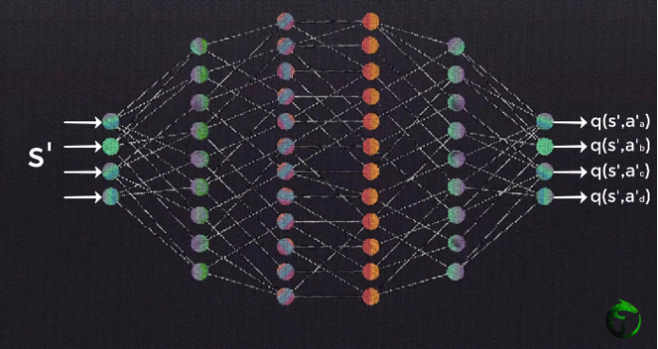

Once we find the value of this maxmax term, we can then calculate this term for the original state input passed to the policy network.

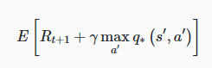

Why do we need to calculate this term again?

Ah, yes, this term enables us to compute the loss between the Q-value given by the policy network for the state-action pair from our original experience tuple and the target optimal Q-value for this same state-action pair.

So, to quickly touch base, note that we first forward passed the state from our experience tuple to the network and got the Q-value for the action from our experience tuple as output. We then passed the next state contained in our experience tuple to the network to find the maxmax Q-value among the next actions that can be taken from that state. This second step was done just to aid us in calculating the loss for our original state-action pair.

This may seem a bit odd, but let it sink in for a minute and see if the idea clicks.

### Training the policy network

Alright, so after we're able to calculate the optimal Q-value for our state-action pair, we can calculate the loss from our policy network between the optimal Q-value and the Q-value that was output from the network for this state-action pair.

Gradient descent is then performed to update the weights in the network in attempts to minimize the loss, just like we’ve seen in all other previous networks we've covered on this channel. In this case, minimizing the loss means that we’re aiming to make the policy network output Q-values for each state-action pair that approximate the target Q-values given by the Bellman equation.



Up to this point, everything we've gone over was all for one single time step. We then move on to the next time step in the episode and do this process again and again time after time until we reach the end of the episode. At that point, we start a new episode, and do that over and over again until we reach the max number of episodes we’ve set. We’ll want to keep repeating this process until we’ve sufficiently minimized the loss.

### Wrapping up

Admittingly, between the [last post](https://deeplizard.com/learn/video/Bcuj2fTH4_4) and this one, that was quite a number of steps, so let's go over this summary to bring it all together.

1. Initialize replay memory capacity.
2. Initialize the network with random weights.
3. *For each episode:*
   1. Initialize the starting state.
   2. *For each time step:*
      1. Select an action.
         * *Via exploration or exploitation*
      2. Execute selected action in an emulator.
      3. Observe reward and next state.
      4. Store experience in replay memory.
      5. Sample random batch from replay memory.
      6. Preprocess states from batch.
      7. Pass batch of preprocessed states to policy network.
      8. Calculate loss between output Q-values and target Q-values.
         * Requires a second pass to the network for the next state
      9. Gradient descent updates weights in the policy network to minimize loss.

We briefly mentioned previously that there were some issues that could arise from this approach though. These issues come into play in step 88 where we calculate the loss between the output Q-values and the target Q-values. Remember, this is the step that requires a second pass to the deep Q-network, otherwise known as the *policy network*.

As a quick refresher, remember, for a single sample, the first pass to the network occurs for the state from the experience tuple that was sampled. The network then outputs the Q-values associated with each possible action that can be taken from that state, and then the loss is calculated between the Q-value for the action from the experience tuple and the target Q-value for this action.

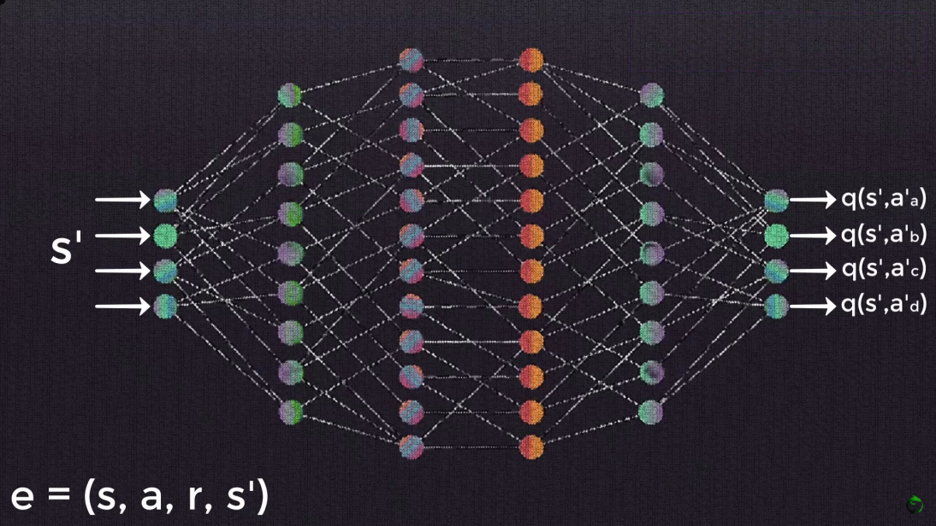

To calculate the target Q-value though, we were required to do a *second* pass to the network with the *next* state. From this second pass, we can obtain the maximum Q-value among the possible actions that can be taken from that next state, and plug that in to the [Bellman equation](https://deeplizard.com/learn/video/rP4oEpQbDm4) to calculate the target Q-value for the action from the first pass.

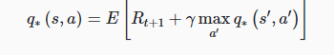

This process is a bit of a earful, I know, so if you're struggling at all, be sure to spend some time on the [previous post](https://deeplizard.com/learn/video/0bt0SjbS3xc) where we cover this in full detail.

### Potential training issues with deep Q-networks

Alright, now that we have that refresher out of the way, let's focus on the potential issues with this process. As mentioned, the issues stem from the second pass to the network.

We do the first pass to calculate the Q-value for the relevant action, and then we do a second pass in order to caluclate the target Q-value for this same action. Our objective is to get the Q-value to approximate the target Q-value.

Remember, we don't know ahead of time what the target Q-value even is, so we attempt to approximate it with the network. This second pass occurs using the same weights in the network as the first pass.

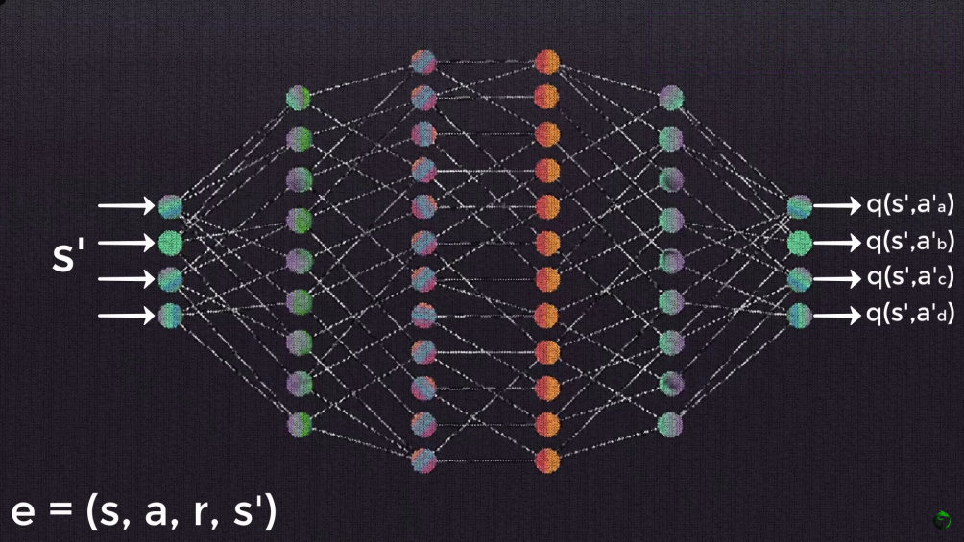

Given this, when our weights update, our outputted Q-values will update, but so will our target Q-values since the targets are calculated using the same weights. So, our Q-values will be updated with each iteration to move closer to the target Q-values, but the target Q-values will also be moving in the same direction.

As Andong put it in the comments of the [last video](https://deeplizard.com/learn/video/0bt0SjbS3xc), this makes the optimization appear to be chasing its own tail, which introduces instability. As our Q-values move closer and closer to their targets, the targets continue to move further and further because we're using the same network to calculate both of these values.

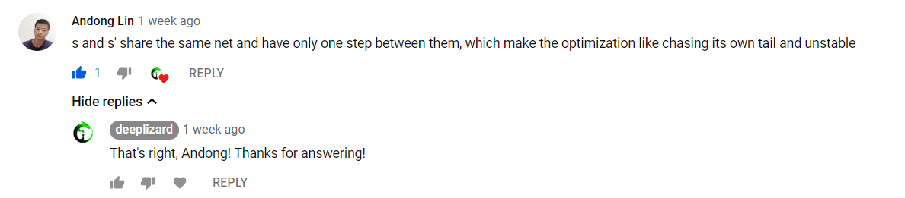

### The target network

Well, here's a perfect time to introduce the second network that we mentioned earlier. Rather than doing a second pass to the policy network to calculate the target Q-values, we instead obtain the target Q-values from a completely separate network, appropriately called the *target network*.

The target network is a clone of the policy network. Its weights are frozen with the original policy network’s weights, and we update the weights in the target network to the policy network’s new weights every certain amount of time steps. This certain amount of time steps can be looked at as yet another hyperparameter that we'll have to test out to see what works best for us.

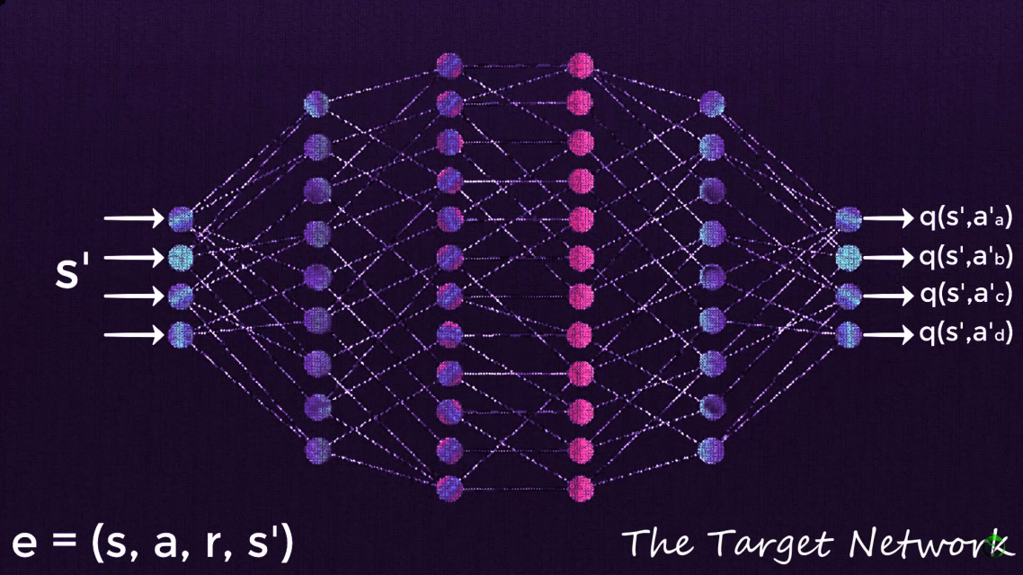

So now, the first pass still occurs with the policy network. The second pass, however, for the following state occurs with the target network. With this target network, we're able to obtain the maxmax Q-value for the next state, and again, plug this value into the Bellman equation in order to calculate the target Q-value for the first state.

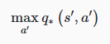

This is all we use the target network for — To find the value of this maxmax term so that we can calculate the target Q-value for any state passed to the policy network.

As it turns out, this removes much of the instability introduced by using only one network to calculate both the Q-values, as well as the target Q-values. We now have something *fixed*, i.e.*fixed Q-targets*, that we want our policy network to approximate. So, we no longer have the dog-chasing-it's-tail problem.

As mentioned though, these values don't stay completely fixed the entire time. After xx amount of time steps, we'll update the weights in the target network with the weights from our policy network, which will in turn, update the target Q-values with respect to what it's learned over those past time steps. This will cause the policy network to start to approximate the updated targets.

**Pytorch installation:**

conda install pytorch-cpu torchvision-cpu –c pytorch